**MAKING OF DESKTOP APPLICATION**

**USING MS ACCESS**

STEP NO. 1: CREATING DOCTORS RECORD, FORMS REPORTS ETC:

Open a blank database sheet. Now start entering field names and fill these columns with respective records.

DATESHEET VIEW

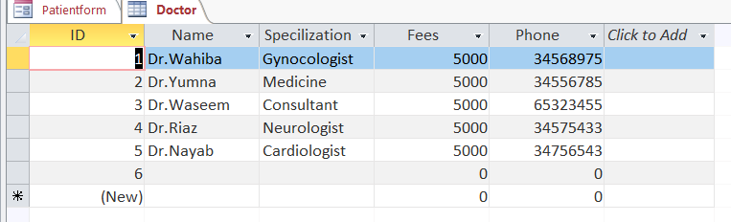

DESIGN VIEW

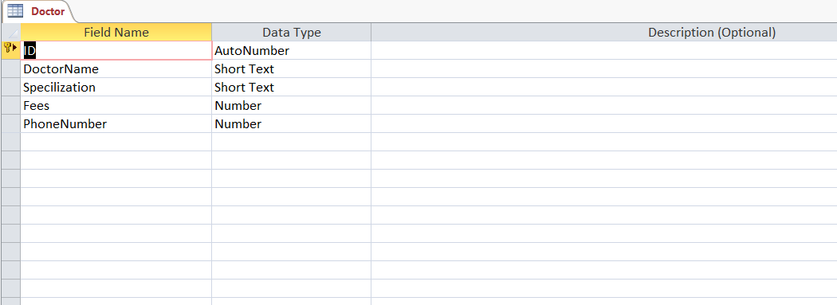

DOCTOR QUERY

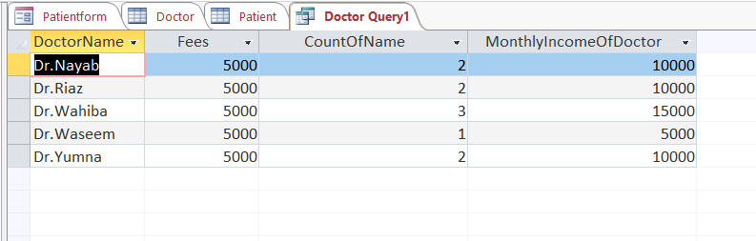

Doctor Query Design View

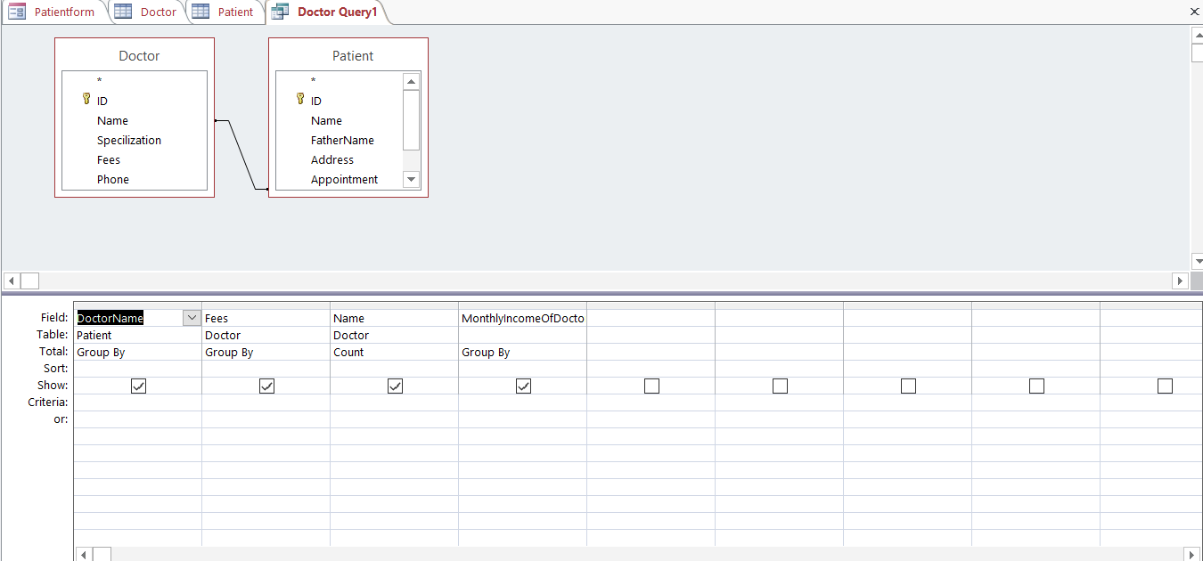

Doctor Query SQL VIew

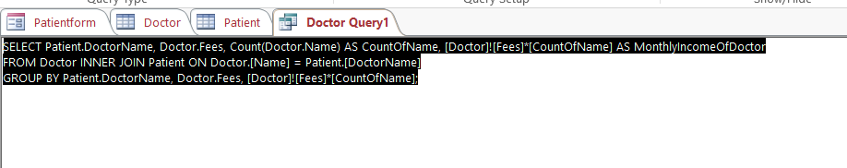

Now click on form to make a form.

Under DESIGN tab, click SUBFORM. Now click on USE EXISTING TABLE AND QUERIES. Click NEXT. Select the fields you want to display. Click NEXT.

Now select the field of your choice which shows record by entering that field. It can be ID, NAME , PHONE ETC. now select a suitable name for your table. Click FINISH when done.

DESIGN VIEW OF DOCTOR FORM

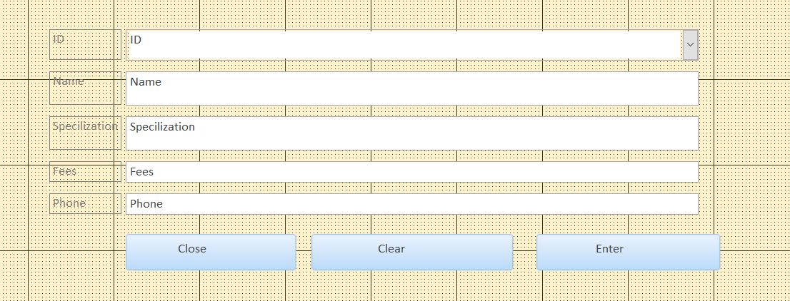

Doctor Form Design View



Doctor SubForm Datesheet View

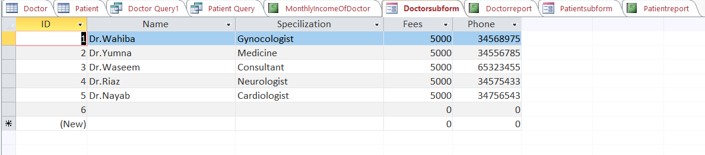

Doctor Subform Design view

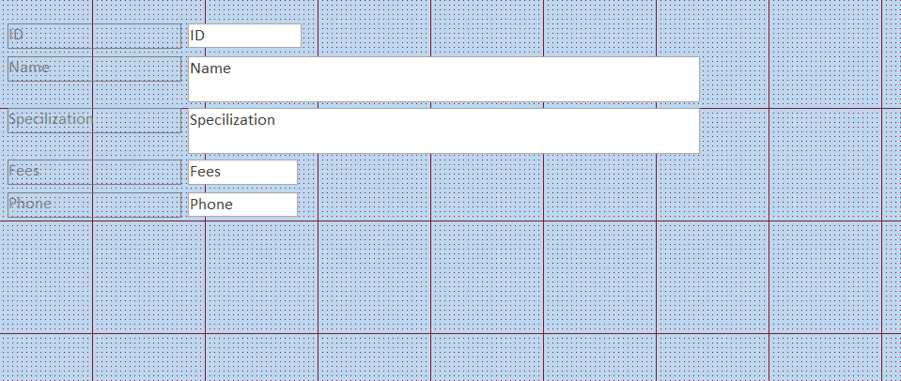

Doctor SubForm From View

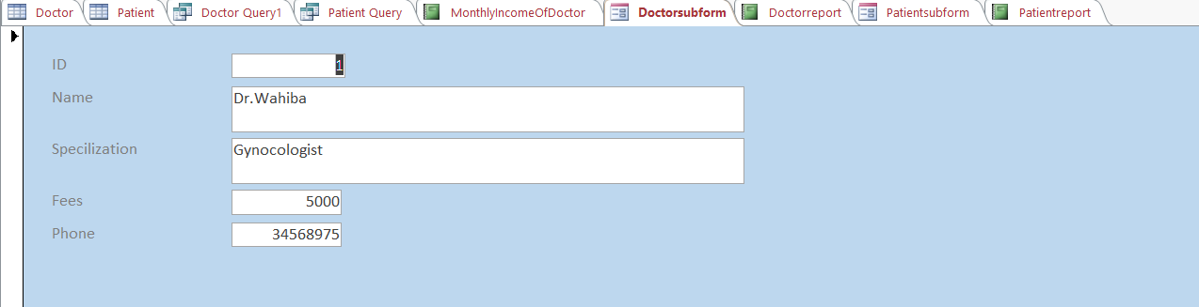

Now click on the buttons , on the right side of the screen a property sheet appears . click EVENT button. Now select EVENT PROCEDURE in ON CLICK.

PROPORTIES OF ENTER, CLEAR & CLOSE BUTTON

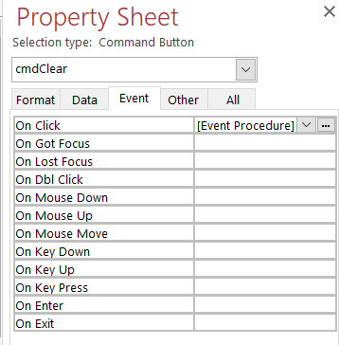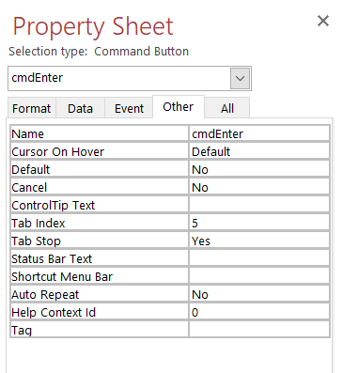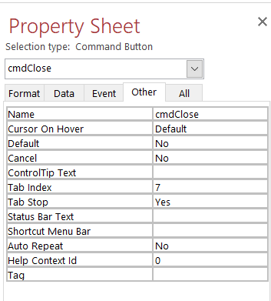

PROPORTIES OF SUBFORM

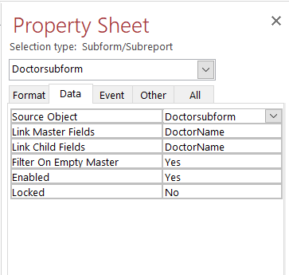

REPORT OF DOCTOR

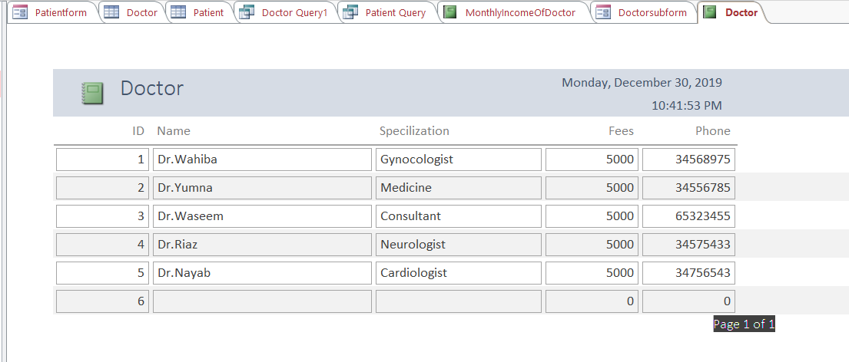

STEP NO. 2: CREATING PATIENT RECORD, FORMS AND REPORTS ETC:

Similarly now make another record, for the patient. start entering field names and fill these columns with respective records.

Then Under DESIGN tab, click SUBFORM. Now click on USE EXISTING TABLE AND QUERIES. Click NEXT. Select the fields you want to display. Click NEXT.

Now select the field of your choice which shows record by entering that field. It can be ID, NAME , PHONE ETC. now select a suitable name for your table. Click FINISH when done.

PATIENT FORM DESIGN VIEW

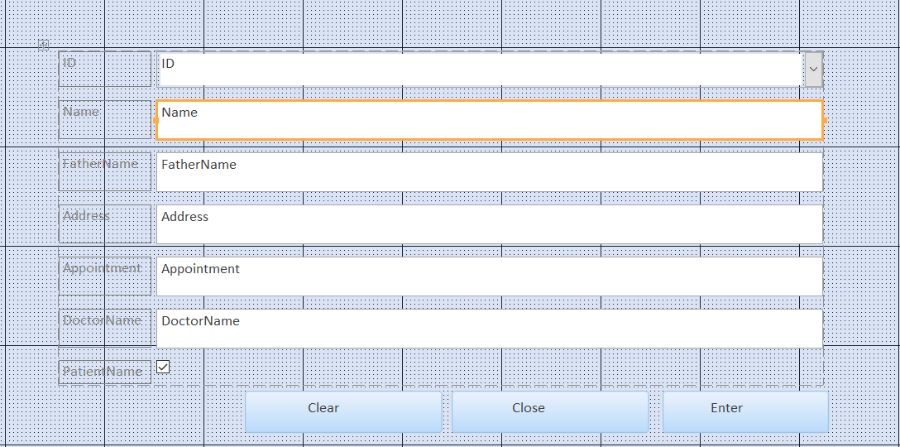

Patient Form

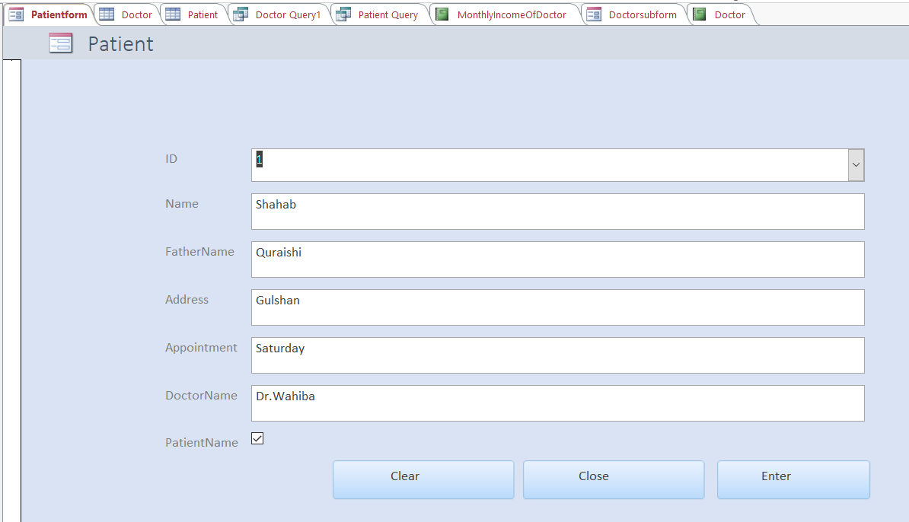

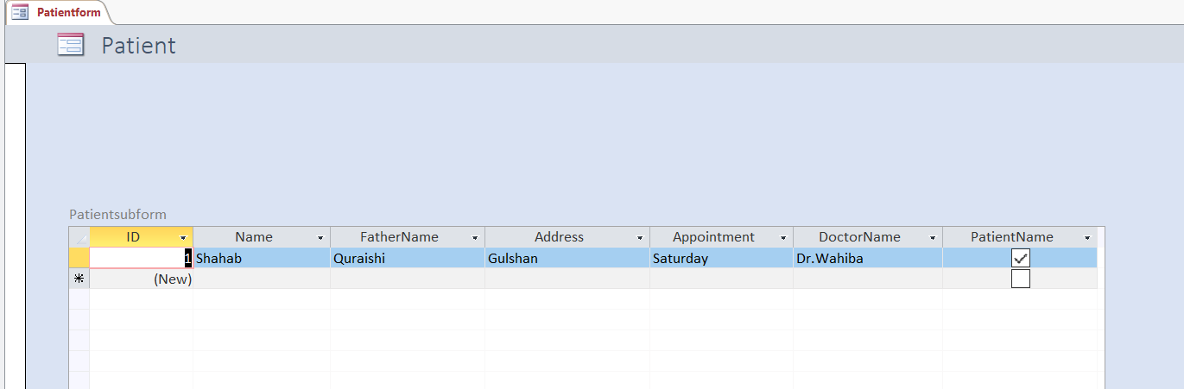

PATIENT SUBFORM DATESHEET VIEW

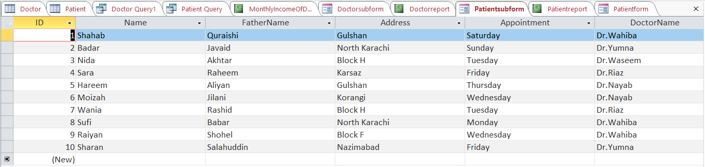

PATIENT SUBFORM DESIGN VIEW

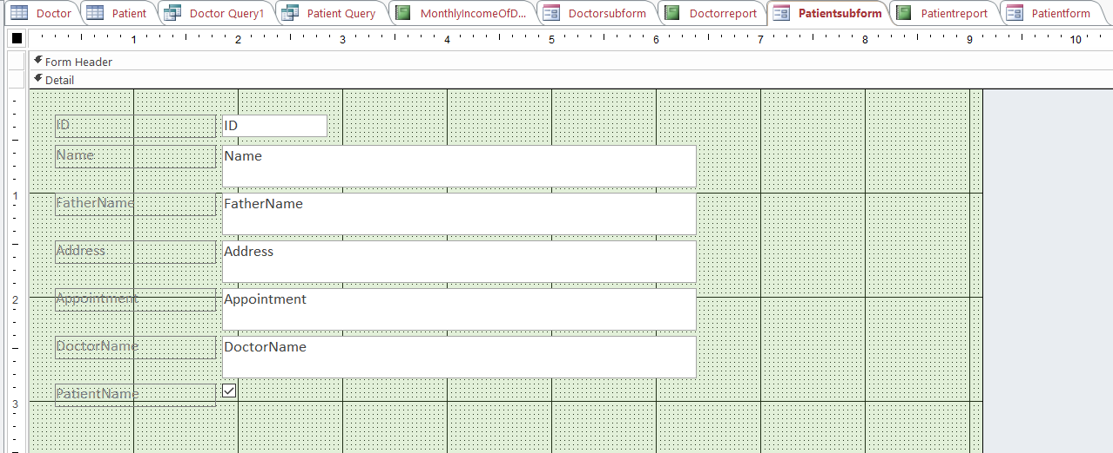

PATIENT SUBFORM VIEW

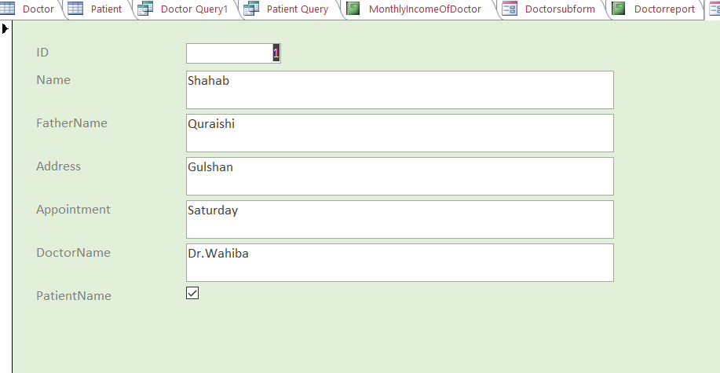

PATIENT REPORT

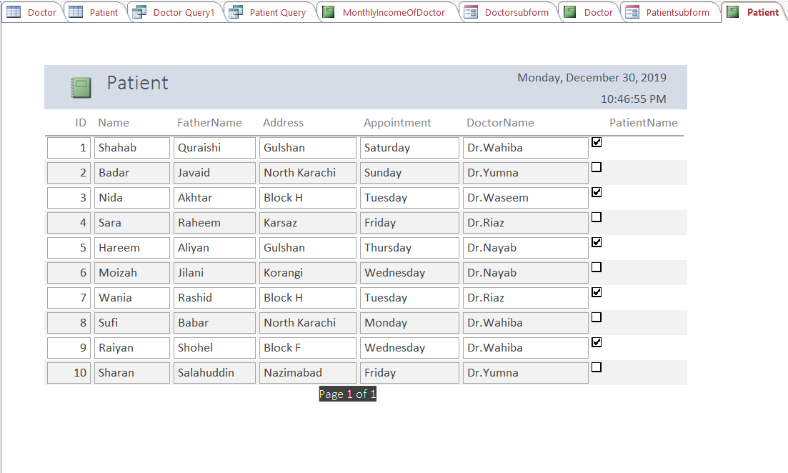

PROPORTIES OF ENTER, CLEAR & CLOSE BUTTON OF PATIENT FORM

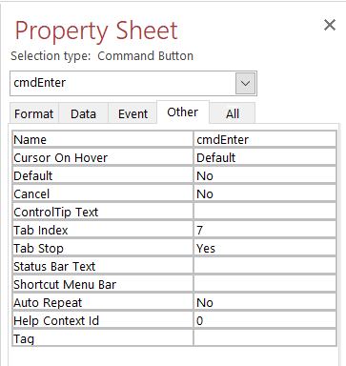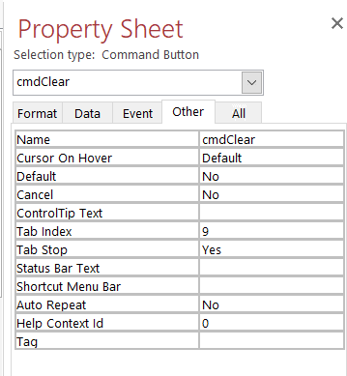

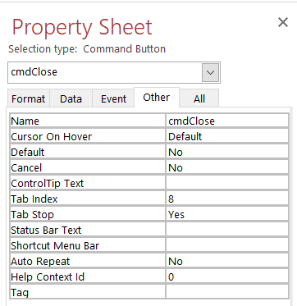

STEP NO. 3: CREATING DOCTORS MONTHLY INCOME RECORDS.

Now make a record by entering doctors name with their monthly income.

MONTHLY INCOME OF DOCTOR

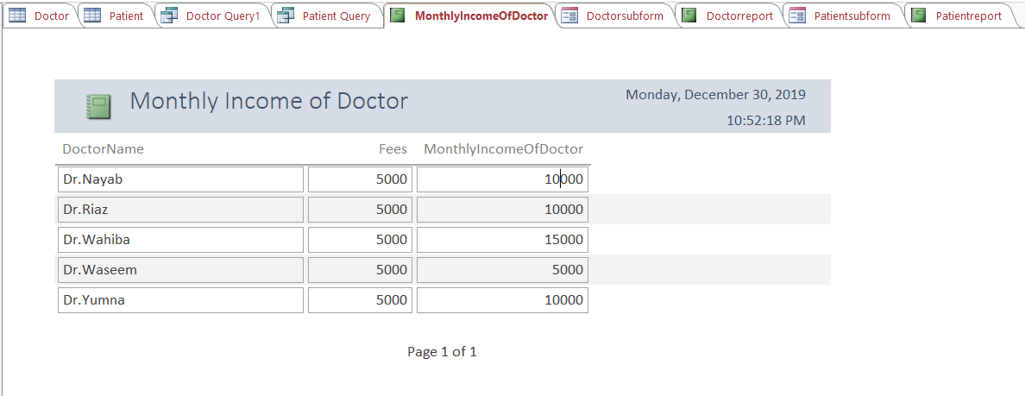

**MAKING OF WEBSITE USING**

**HTML, CSS, BOOTSTRAP, JAVA AND**

**FONT AWESOME 4.**

STEP NO.1: Make three html files.

STEP NO.2: Relate them using a link.

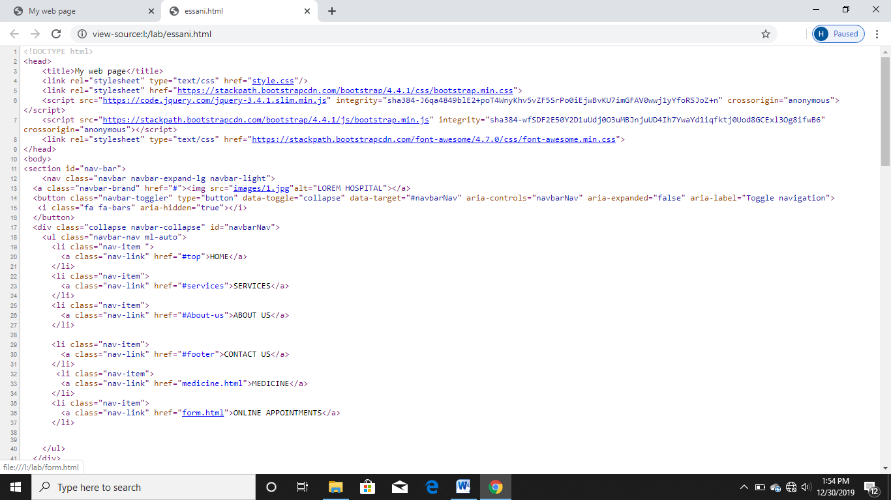

STEP NO.3: Make another file named style.css and relate it with previously made html files.



STEP NO.4: Copy paste the bootstrap and awesome4 code into html files.



STEP NO.5: Download smooth scroll from Github.

